|  |
| --- |
| **Roulette** |
|  |
| ***DE Lab Project Report*** |
| ***Submitted By*** |
| **Shubham Jain (18BCS4501)**  **Raghav Goel (18BCS4505)** |
| ***Under the Guidance of*** |
| **Mr. Anshul Sharma**  **Mr. Divneet Singh Kapoor**  **Mr. Khushal Thakur** |
| **Assistant Professors, Academic Unit – 1** |
|  |
| **Academic Unit-1**  **Chandigarh University** |

**Table of Contents**

1. Problem Identification .......................................................................................................... 1

2. Features................................................................................................................................. 2

3. Design flow........................................................................................................................... 3

4. Outcome................................................................................................................................ 4

5. Cost Analysis......................................................................................................................... 6

**1. Problem Identification**

**Roulette** games can be commonly seen in casinos and clubs. It is a playing device having a large conical shaped wheel with numbers or scores printed on its pockets in a special random manner.

The electronic version of such a roulette game is presented here and is perhaps one of the simplest electronic casino home games. Though not as complex as its original mechanical counterpart but nevertheless can be pretty amusing to actually build it and witness the results.

In traditional Roulette chances of cheating can be high, as by using magnets the tale or the ball can be stopped at a particular number which is unfair and can cause heavy loss of capital, by using electronic version of roulette the chances can be reduced as magnets or strings can’t stop the blinking led’s.

**2. Features**

1. It is a cheap product as compared to traditional wooden made Roulettes.
2. It is also portable.
3. Easy to use, no technical knowledge required.
4. Less chances of cheating.
5. Not easy to hack.
6. No wireless component used.
7. In electronic gaming circuits.
8. As a random number generator.
9. In touch intuitive decorative lighting setups.

**3. Design Flow**

**Block Diagram**

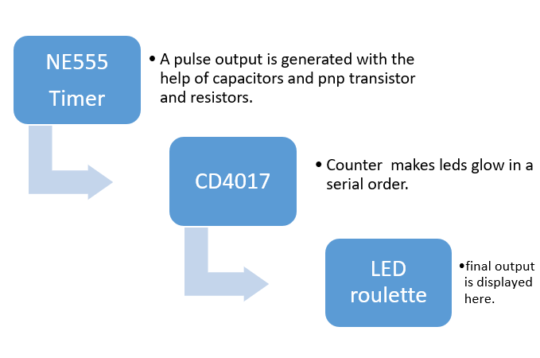**Circuit Diagram**

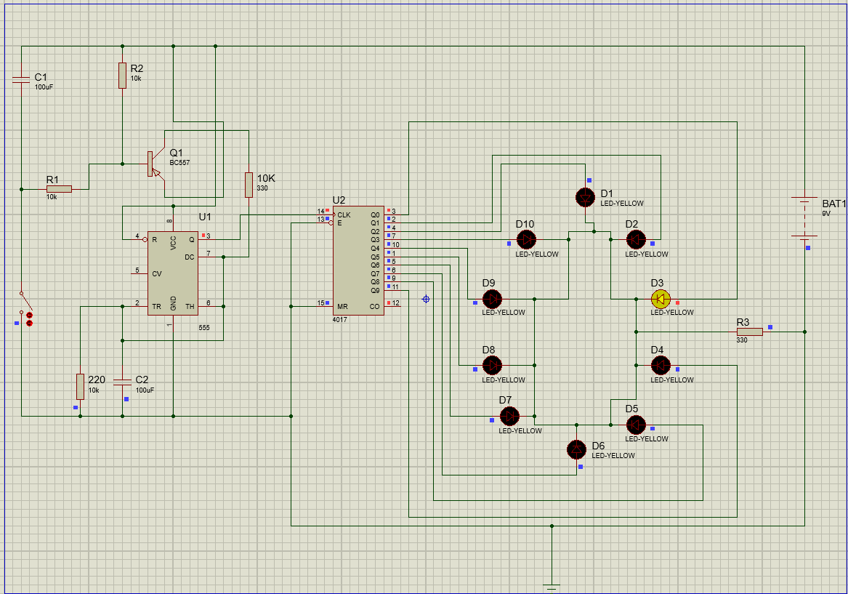

# Material Used

1. *NE 555 timer IC*  x1

|  |  |
| --- | --- |
| Supply voltage (VCC) | 4.5 to 15 V |
| Output current (maximum) | 200 mA |
| Maximum Power dissipation | 600 mW |
| Power consumption (minimum operating) | 30 mW@5V, 225 mW@15V |
| Operating temperature | 0 to 75 °C |

1. *CD 4017 IC*  x1

The 555 IC will operate in a stable mode with a frequency of 14Hz. The 555 IC in the circuit is used as a clock pulse generator to provide input clock pulses to the counter IC4017. The clock pulses generated at the output of IC 555 timer (PIN-3) is given as an input to IC 4017 through many PINS.

1. *Yellow LED’s* x10

Allows you to optimally power your LEDs to maximize output. ... The 8mm LED is a specially designed LED module with a 140-degree viewing angle. In addition, the 8mm LED has a forward current of 150ma (for a power dissipation of 0.5 watts).

1. *BC 547 transistor* x1

It is mainly used for amplification and switching purposes. It has a maximum current gain of 800. Its equivalent transistors are BC548 and BC549.

1. *100uF capacitors* x2

|  |  |
| --- | --- |
| Lifetime @ Temp | 2000Hrs@105℃ |
| Tolerance | ±20% |
| Capacitance | 100uF |
| Size(mm) | 8x12 |

1. *10k, 330ohm resistors* x3,2

Use to stop the overflow of current.

1. *Switch* x1

To allow and disallow the flow of current.

1. *9V battery* x1

Provides power to the circuit.

1. *Jumper wires* x20

Used for connections.

1. *Bread board* x2

For joining the components and make circuit.

**5. Outcome**

# Steps of Circuit Completion

1. The 1uF capacitor charges because of current flowing through finger. When a capacitor charges, the voltage at its positive terminal approaches the voltage of positive rail, and the voltage at its negative terminal approaches the voltage of negative rail. And since the negative terminal of capacitor is connected to the base of transistor via a 10k resistor, the voltage at the base of transistor will be more towards negative rail.
2. The transistor is of pnp type. So, if the voltage at its base is more towards negative, the transistor gets biased and starts conducting current between its emitter & collector pins. Otherwise no current flows between them. So more the negative voltage at the base of transistor, more will be the conductivity between its emitter & collector pins.
3. One terminal of 100uF capacitor near the 555 timer IC is connected to negative rail and the other is connected to positive rail via a 10K resistor & transistor. And the speed with which this 100n capacitor can charge or discharge determines the frequency of output square wave from 555 timer IC. Since the conductivity of transistor increases, the 100n capacitor will be able to charge quickly and so the frequency of output wave from 555 timer IC increases.
4. The output of 555 timer IC is connected to the clock input of 4017 IC. Also, the speed of rotation of the LED's is directly proportional to the frequency of clock input signal of 4017, which is the same as frequency of output wave from 555 timer IC. So, the LED's start rotating faster.
5. **When we remove finger from touch-contacts.**
6. The 1uF capacitor discharges slowly, so the conductivity between emitter & collector of transistor decreases, so 100nF capacitor takes more and more time for it to charge. So, the frequency of output from 555 timer IC increases and as a result, the speed of rotation of the LED's reduce and finally they come to a halt. (Since frequency of wave at the clock input of 4017 IC is same as frequency of output wave from 555 timer IC).

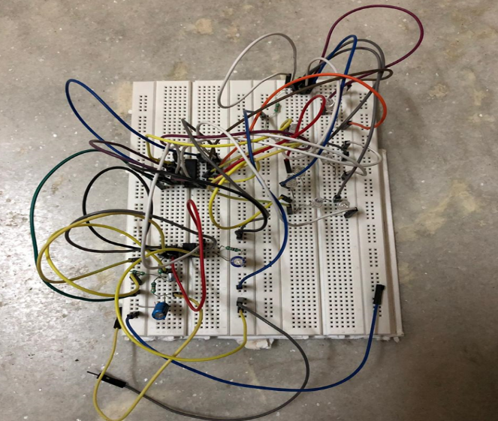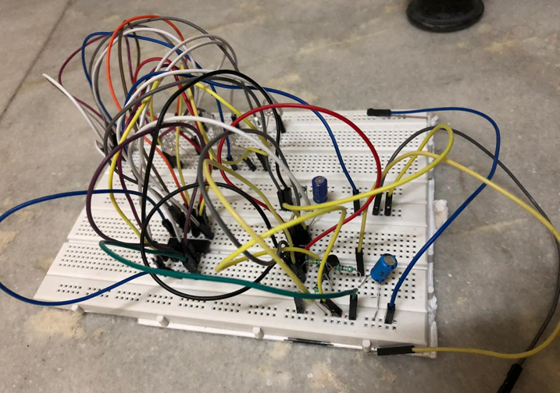

**6. Cost Analysis**

|  |  |  |
| --- | --- | --- |
| **S.No.** | **Components / Material** | **Price (in Rs.)** |
| **1.** | 555 Timer IC | 10 |
| **2.** | CD 4017 IC | 22 |
| **3.** | LED Lights x10 | 10 |
| **4.** | Resistors: 330R, 10K, | 15 |
| **5.** | Capacitors: 100uF | 20 |
| **6.** | Breadboard | 120 |
| **7.** | Power Supply: (5-12) V | 40 |
| **Total** | | **237** |

**7. Reference manual/Lab manual for the designed experiment**

***(to be seFor Govt. funded project only)***

1. Aim
2. Components required
3. Setup requirements
4. Procedure for data collection
5. Calculations
6. Observation ( two samples as observation)
7. Result